Final Regression Report

Introduction: context and background info
With over 310 million active users and more than 200 million Prime subscribers, Amazon is the world’s most widely used online retailer. In fact, roughly 80 - 83% of U.S. (over 100 million U.S. households) shop on Amazon (capitaloneshopping.com), meaning that multiple individuals within a single household often share the same Amazon account. Predicting the number of individuals within a household is valuable information for businesses to understand spending behaviors and tailor product recommendations. In our analysis, factors such as order frequency, total purchase amount, and number of unique items were strong predictors of household size. Other factors like month and day of order and the presence of child-related-product categories (baby bottle, changing table, baby food, etc.) also contributed as well.

Exploratory Data Analysis

Distribution of Household Size
To get started, we first evaluate the distribution of household size for the training data, with the x-axis being the household size and the y-axis being the count for each household size. The chart captures the observed household range from one to four people, with the most common size being two people. It is also important to note that there may be larger household sizes, but the largest household size that someone could report was 4, so this will also be the maximum value in the test data. This suggests that the majority of households in the data are relatively small, and the chart provides a gauge of what sizes we can expect for our models.
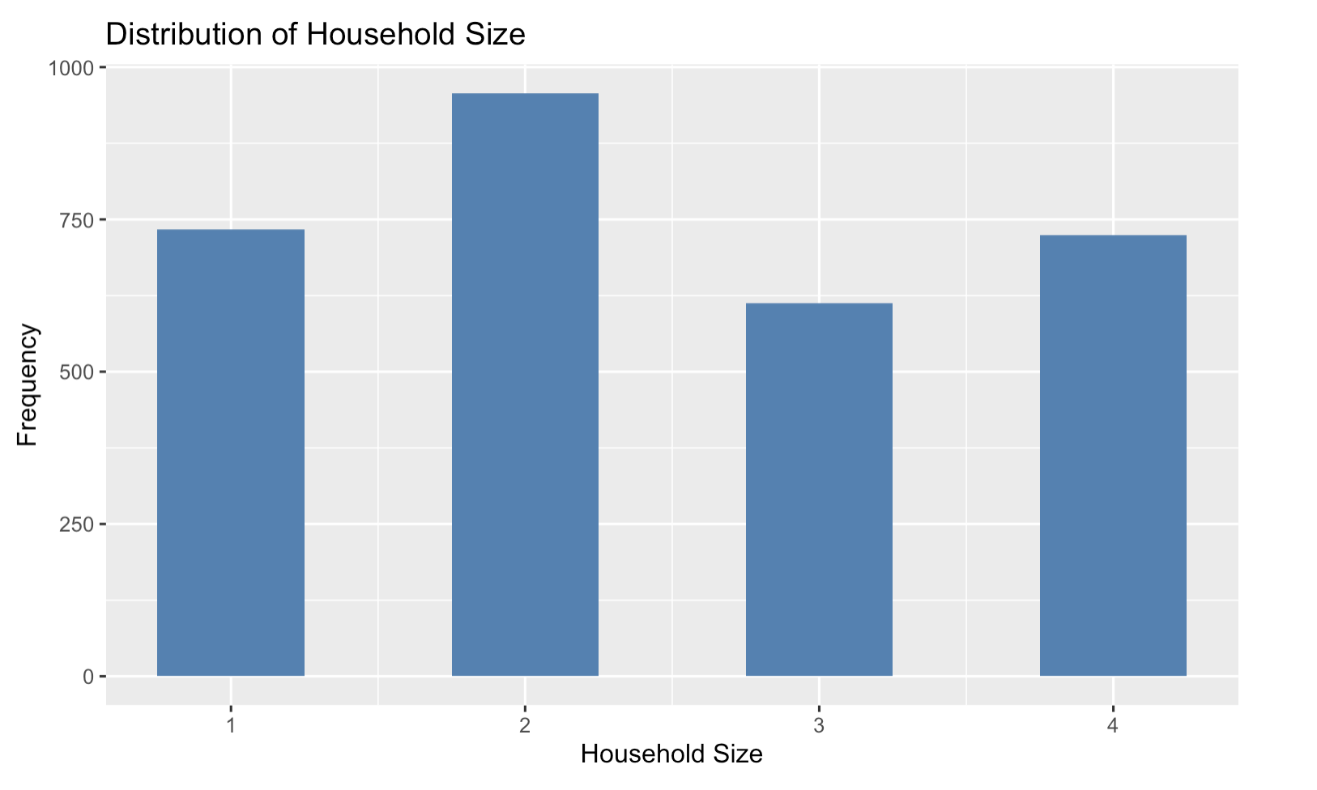

Household Size by Child Indicator

This barplot visualizes the percentage of households that have purchased at least one item that we designated as a “child indicator”. These are items with product categories such as “children toy” or “school supplies” that we thought might indicate having children and a larger household size. We can see that the larger the household sizes have a larger proportion of observations that have purchased children related items. When included in our models, we would expect the presence of a child indicator to increase the predicted household size.
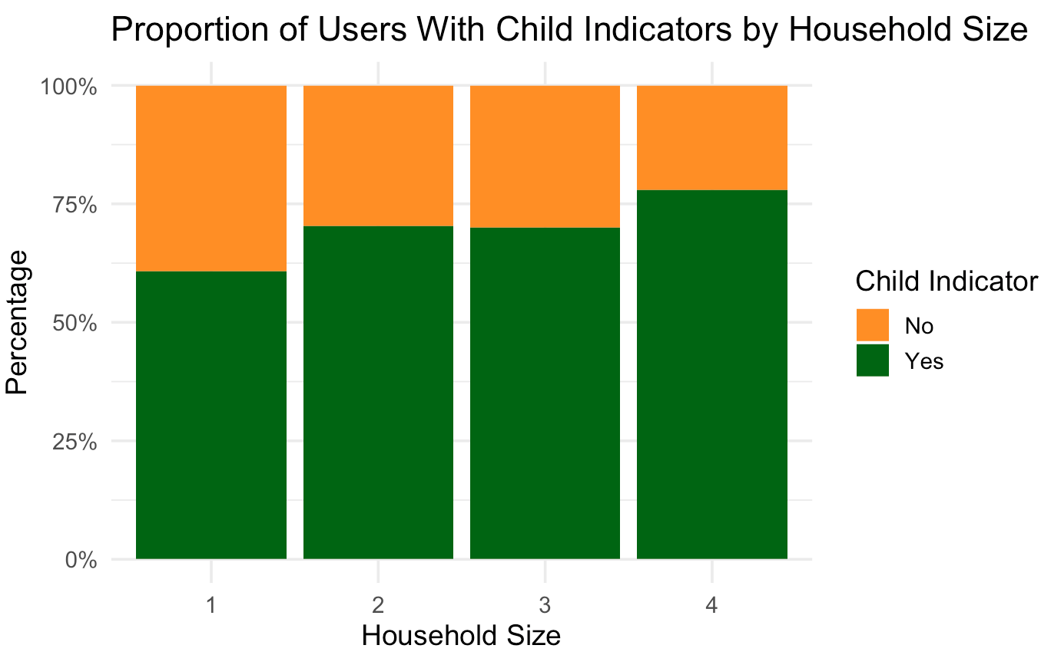

Household Size and Total Purchase Amount
The scatter plot demonstrates the distribution of total purchase amounts organized by household size for the training data, where each point represents a household. The plot demonstrates how, as household size increases, the total purchase amount tends to increase as well. The spread, or variability, of purchase amounts also increases with household size. The graph provides an overview of general trends and outliers in purchasing behavior relative to household size.
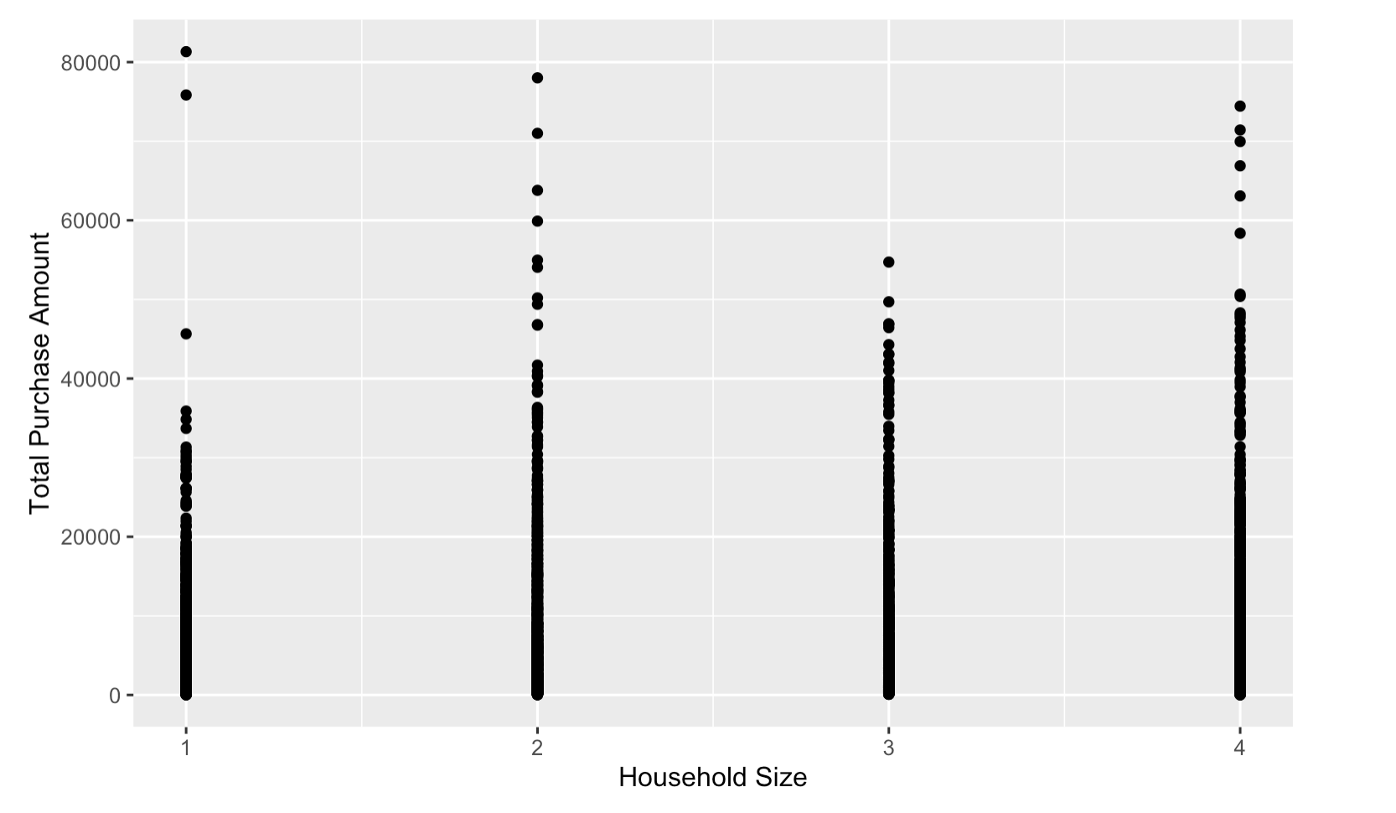

Household Size and Unique Items Ordered
Similar to the previous chart, the boxplot captures the relationship between household size and unique items ordered for the training data, where each point represents a household. Unlike in the previous chart, as household size increases, unique orders increase as well. The spread of the data, or the variance, also increases with household size, along with outlier concentrations. The graph provides an overview of general trends and outliers in unique order frequency behavior relative to household size.
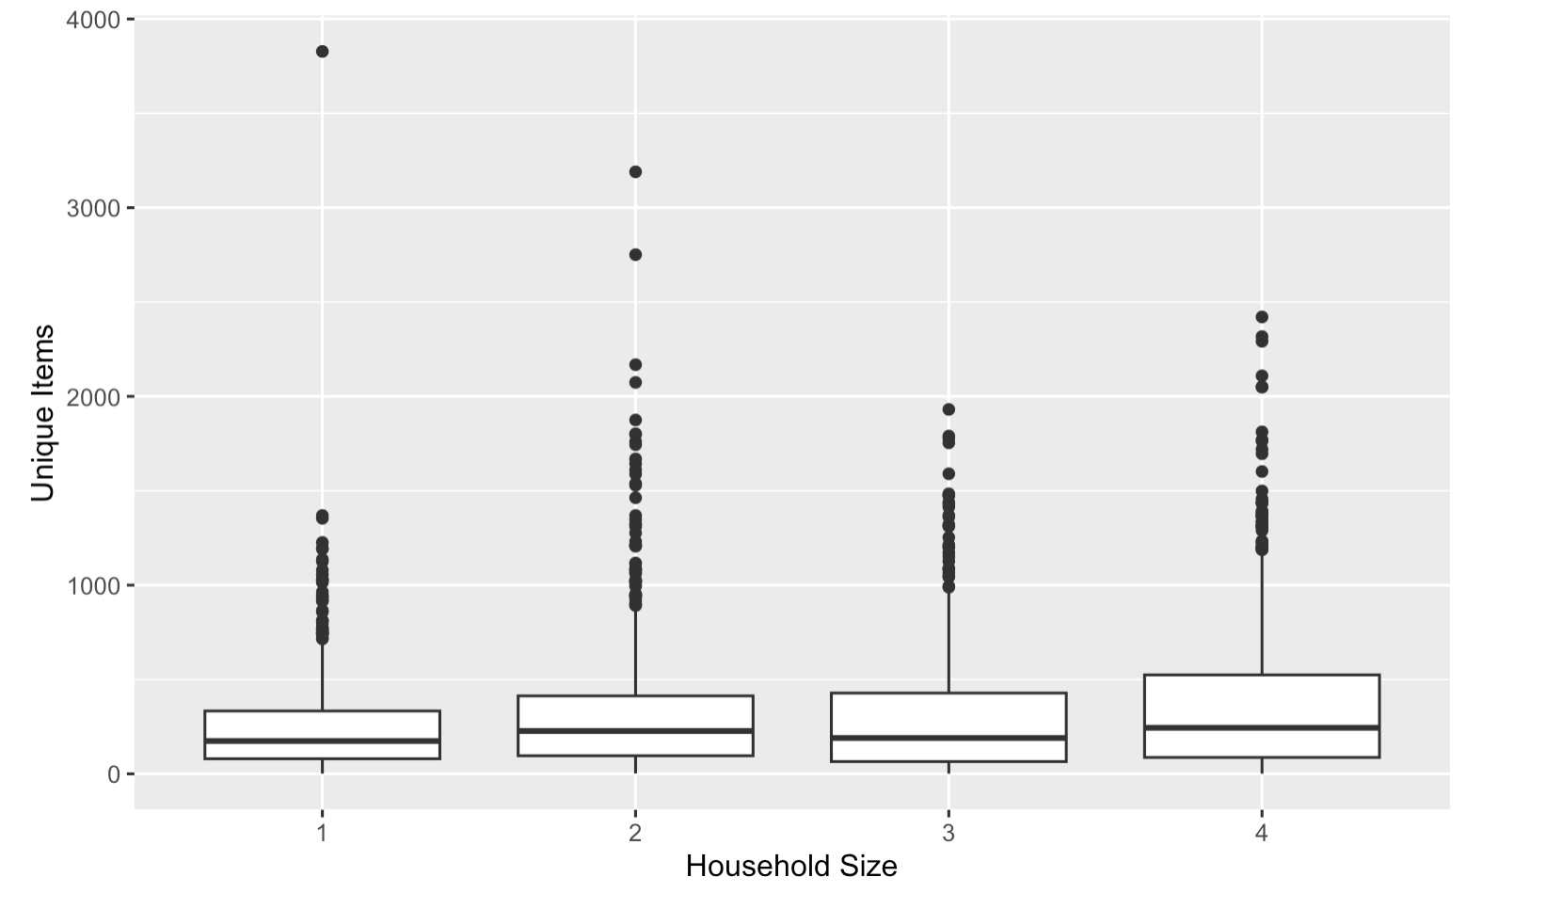

Average Household Size by State
The map captures the relationship between state and average household size for the training data, with yellow indicating large households and blue indicating smaller households. Based on the map, midwestern states tend to have smaller average households, while states along the coastlines have larger average households, with the exception of Vermont which has an exceptionally small household average. The graph provides an overview of general trends in average household size relative to survey state information.

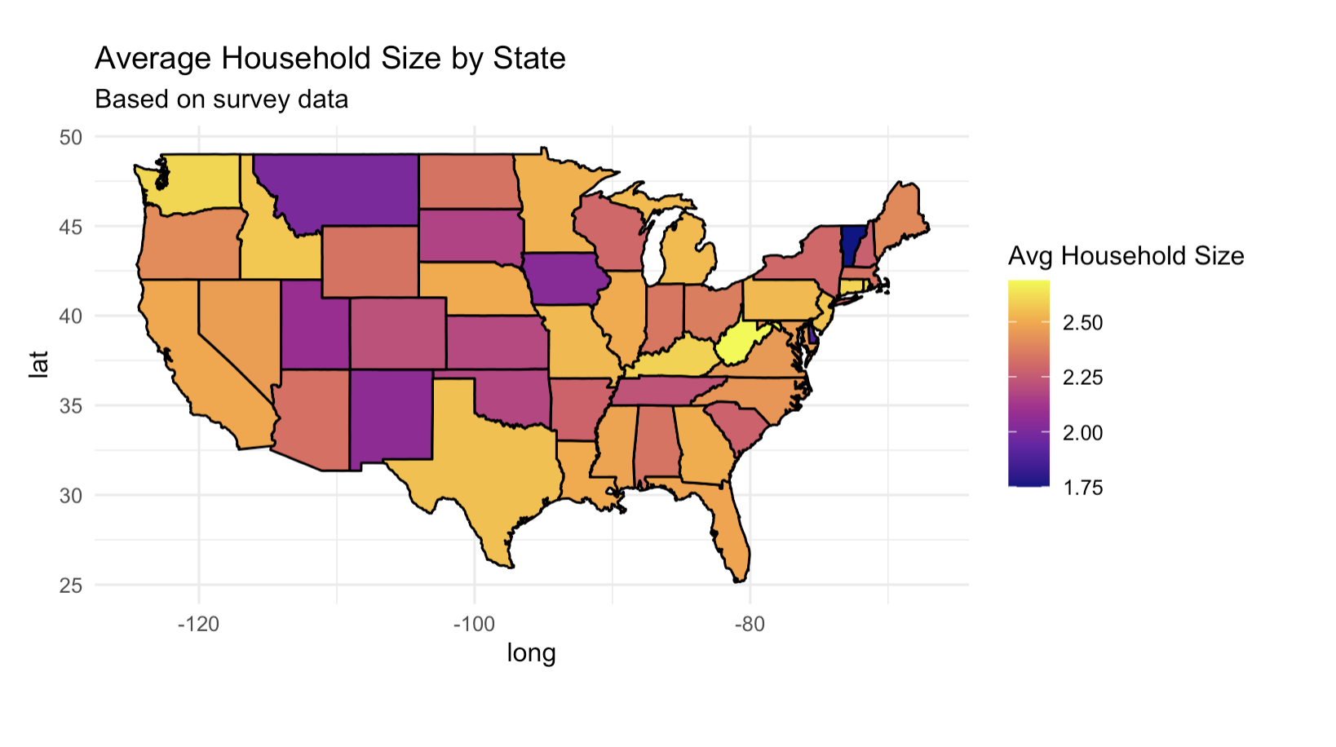

Total Orders Per User
The histogram portrays the distribution of the number of orders per user and the number of users across the training data. The x-axis represents the number of orders and the y-axis represents the count of users. The data is skewed right, indicating that most users place relatively few orders with a smaller number of users that place many. The skew suggests that variable transformations, such as logarithmic transformations, may be beneficial when defining features for our models. The number of orders may contribute to determining household size, with a higher number of orders indicating a potentially larger household.
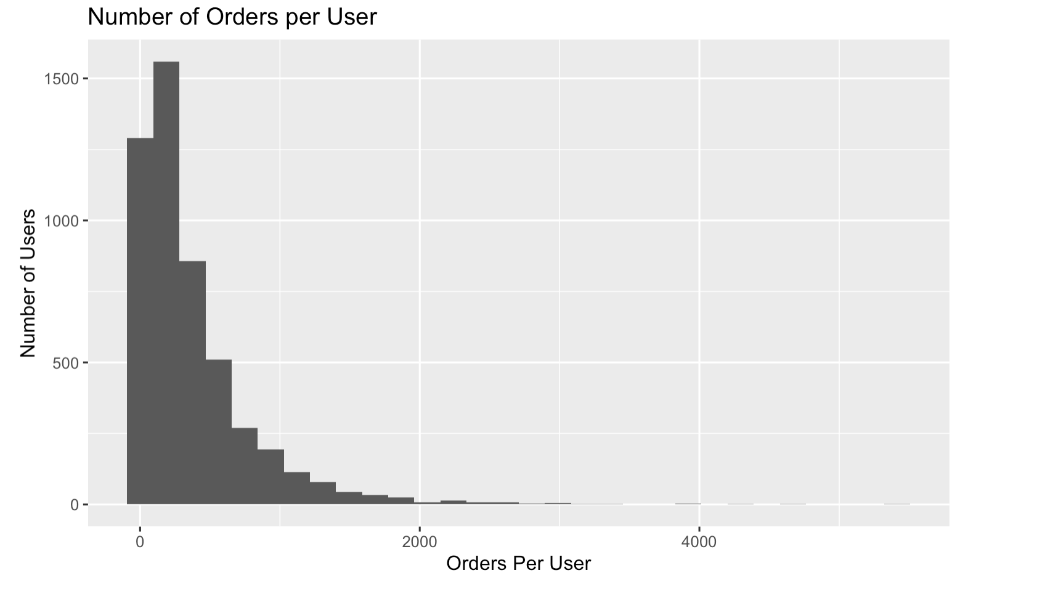

Average Number of Days Between Orders
The histogram captures the distribution of order frequency and the total number of users for the training data. The x-axis represents the average interval, in days, between a user’s consecutive orders, while the y-axis shows how many users have a particular order frequency. The chart is skewed right because most users place orders relatively frequently, with a smaller number of less frequent purchasers. The chart helps reveal the gaps between purchases and variability in order frequency by users. The purchase frequency contributes to determining household size, with a higher frequency of orders potentially indicating a larger household.
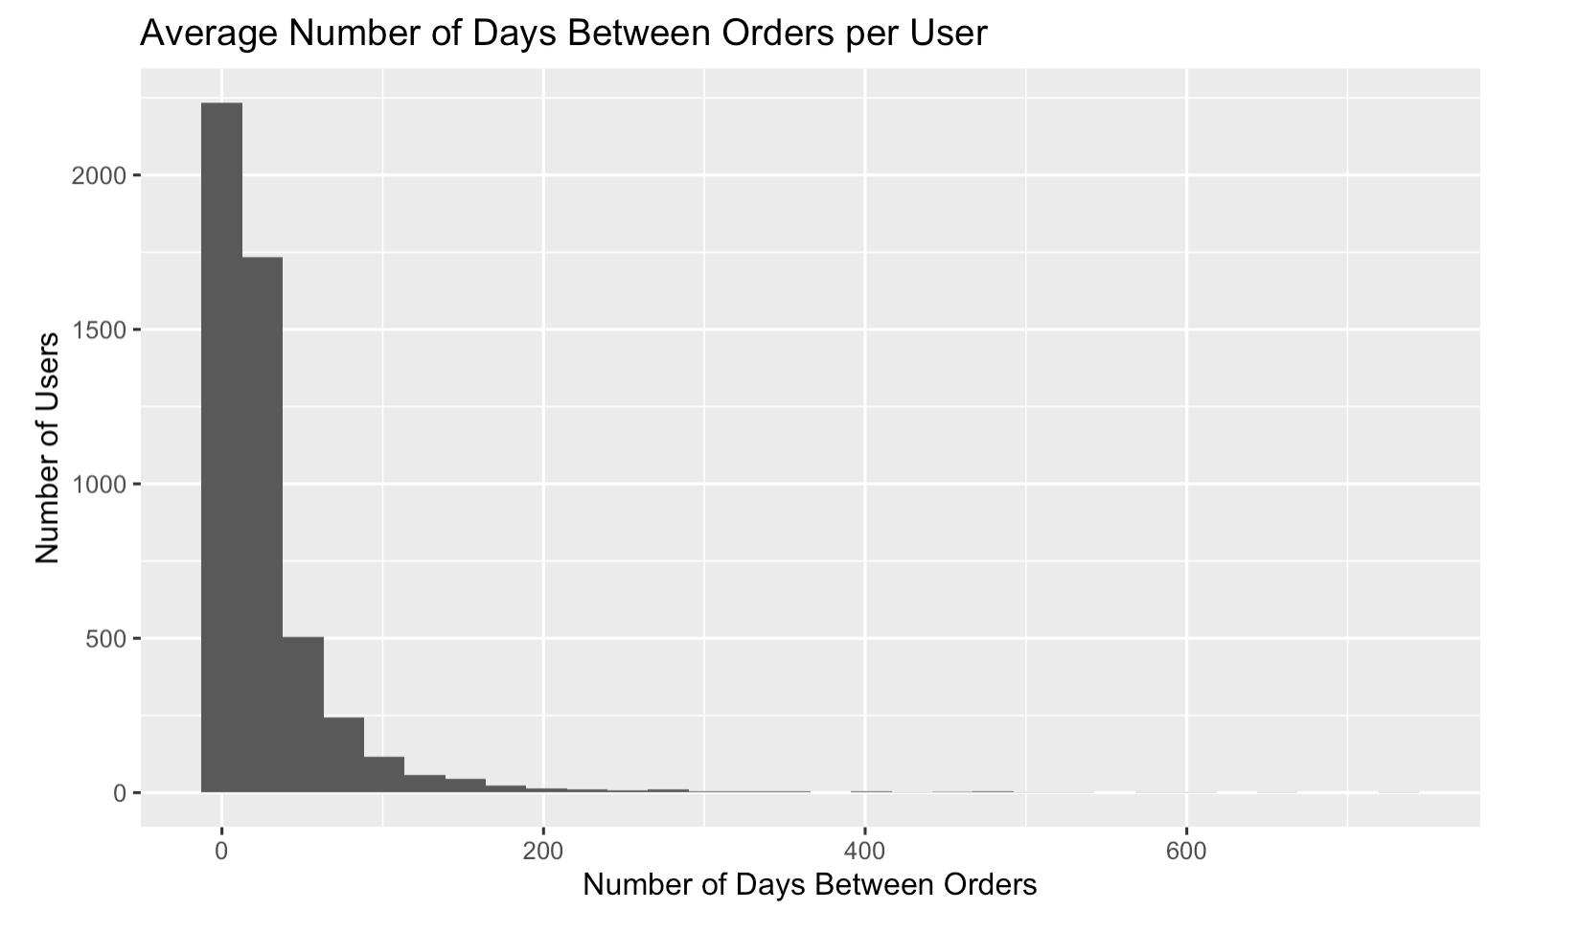

Users by Number of Unique States Shipped
The histogram captures the distribution of the number of unique states each user shipped to for the training data. The x-axis is the number of unique states, while the y-axis is the user count. The chart is skewed right, indicating that most users ship to only a few states, while a smaller number of users ship to many states. The states shipped to could potentially indicate household size.
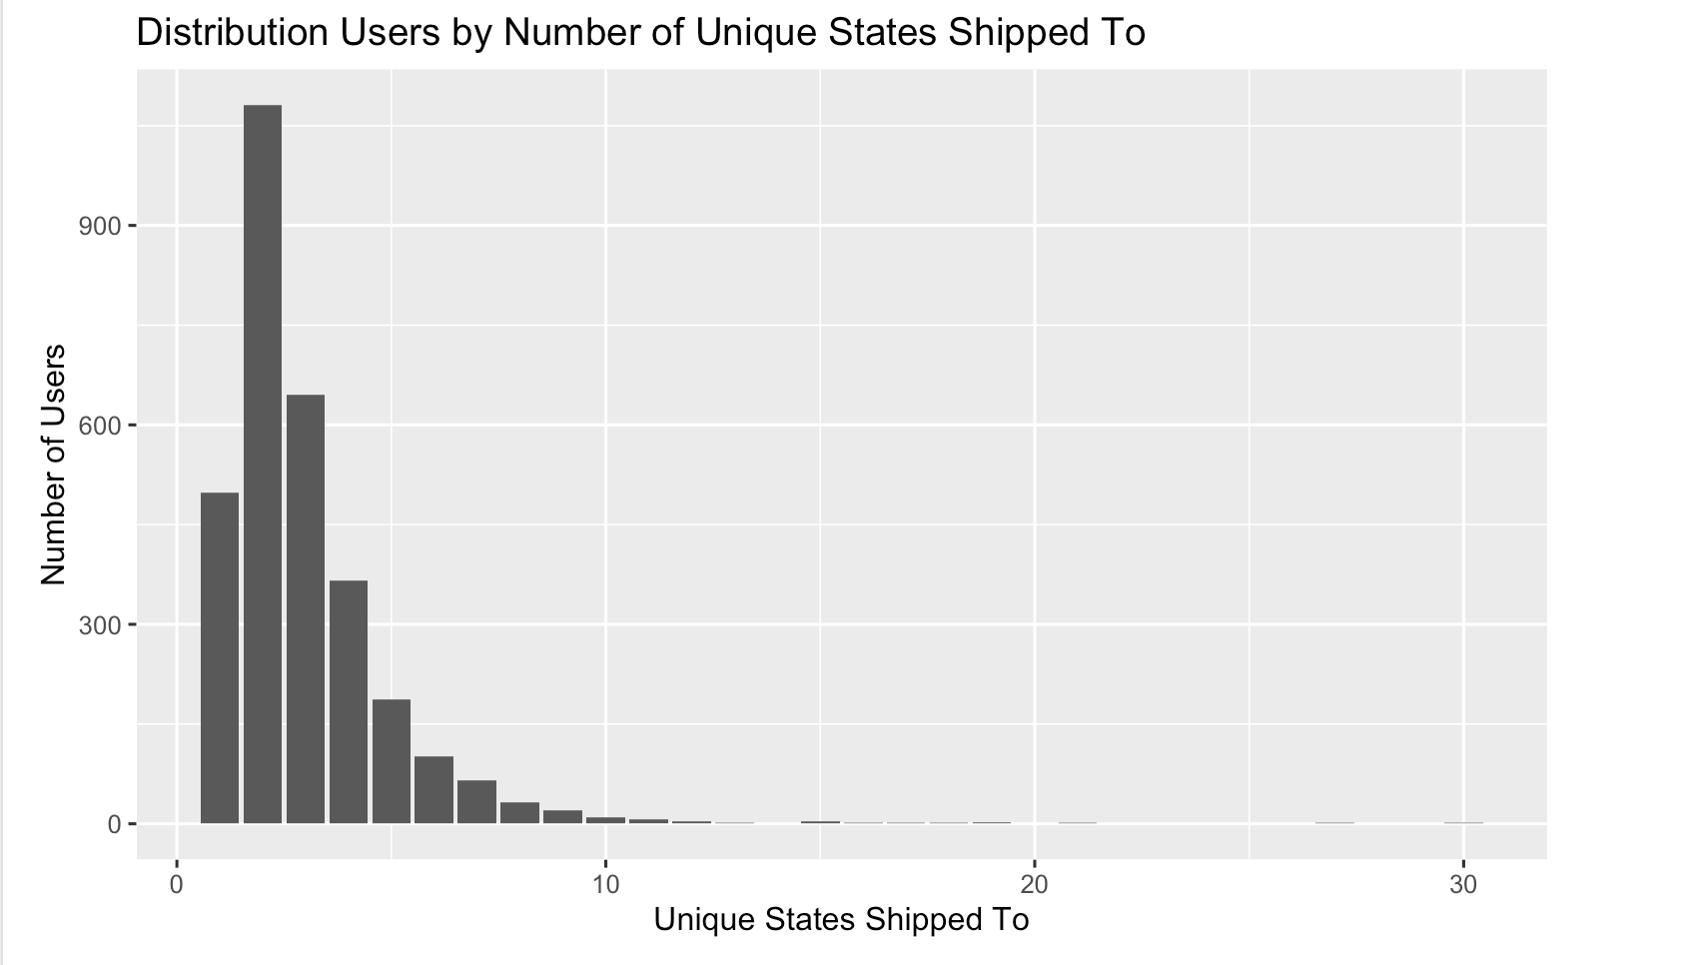

Distribution of Quantity Variables
The visualization below shows the distribution of the number of items bought in the following categories: child-related items, grocery items, household items, and pet items. Noticing the right skew of all these variables suggests that some sort of transformation could possibly be beneficial for these variables.

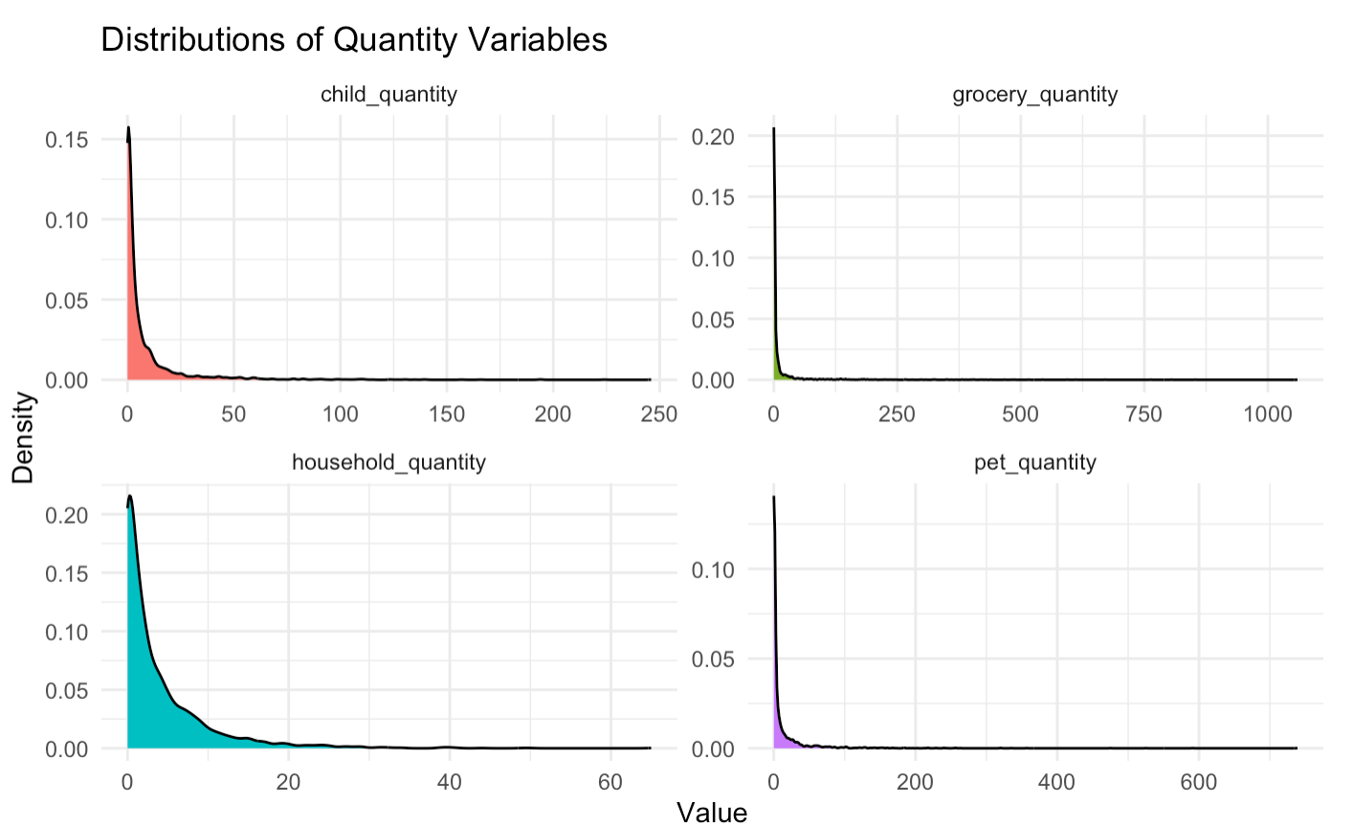

Purchase Trends Over Time
The histogram displays the frequency of purchases made over time within the purchases dataset. The x-axis represents the time (grouped into bucket intervals), while the y-axis shows the number of purchases within each interval. The chart highlights how purchase trends increase from 2018 to 2022, revealing possible seasonal patterns. This chart provides context about overall purchasing trends, but does not directly indicate household size. This provides a quick snapshot of the scope of our order data.
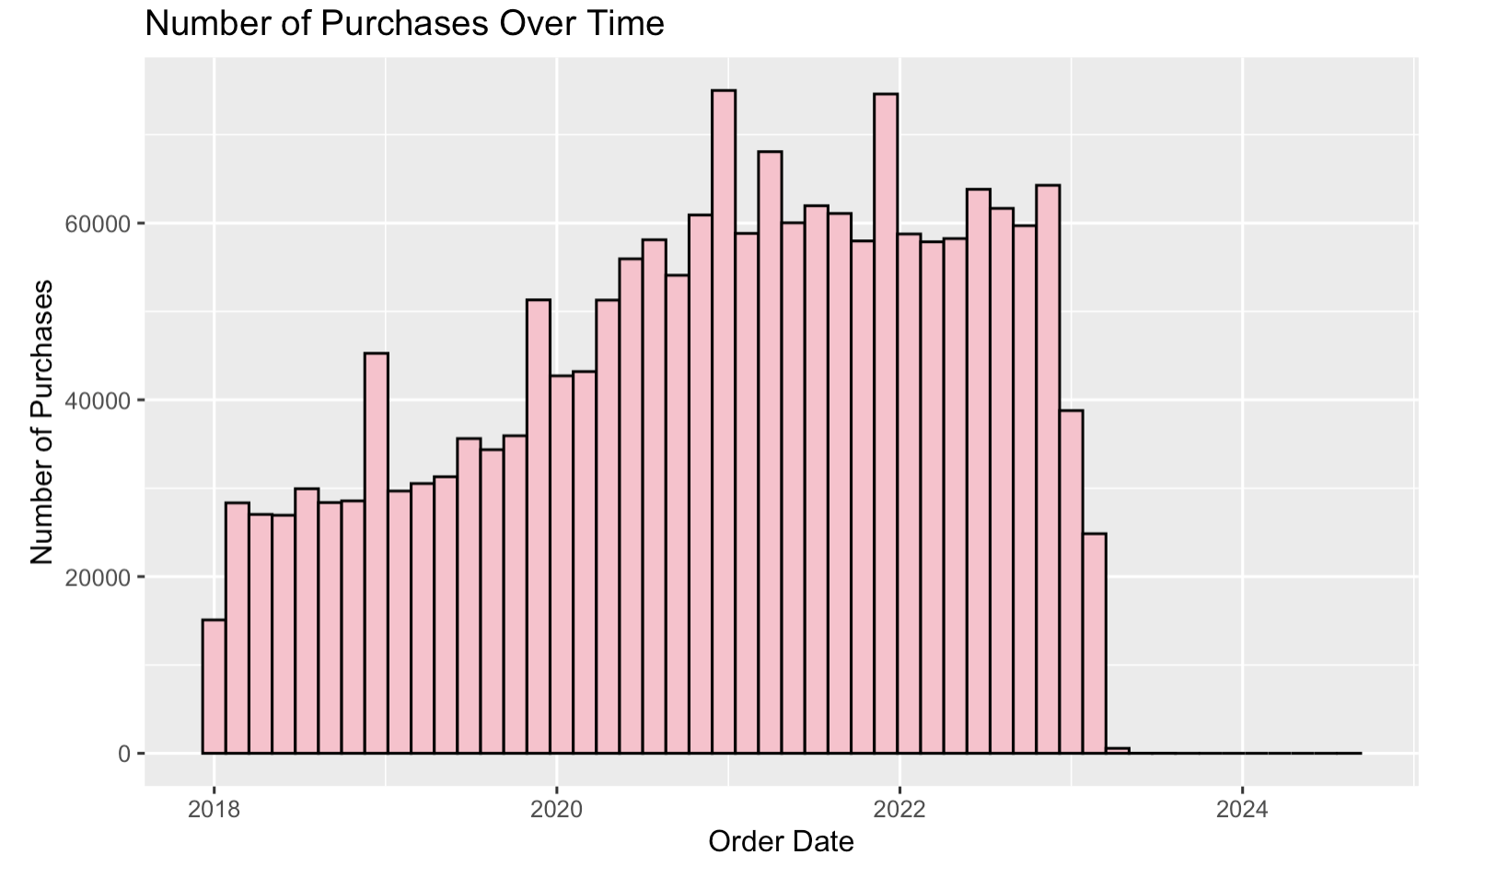

Purchases by Shipping State
The bar chart captures the purchasing distribution by shipping state across the entire purchases dataset. The x-axis is the shipping address state, and the y-axis portrays the total number of purchases for each state. California and Texas have the highest purchase counts among all states. When combined with the map showing average household size by state, these purchase quantities can contribute to the household size models by exploring whether higher purchase volumes correspond to states with larger average households.
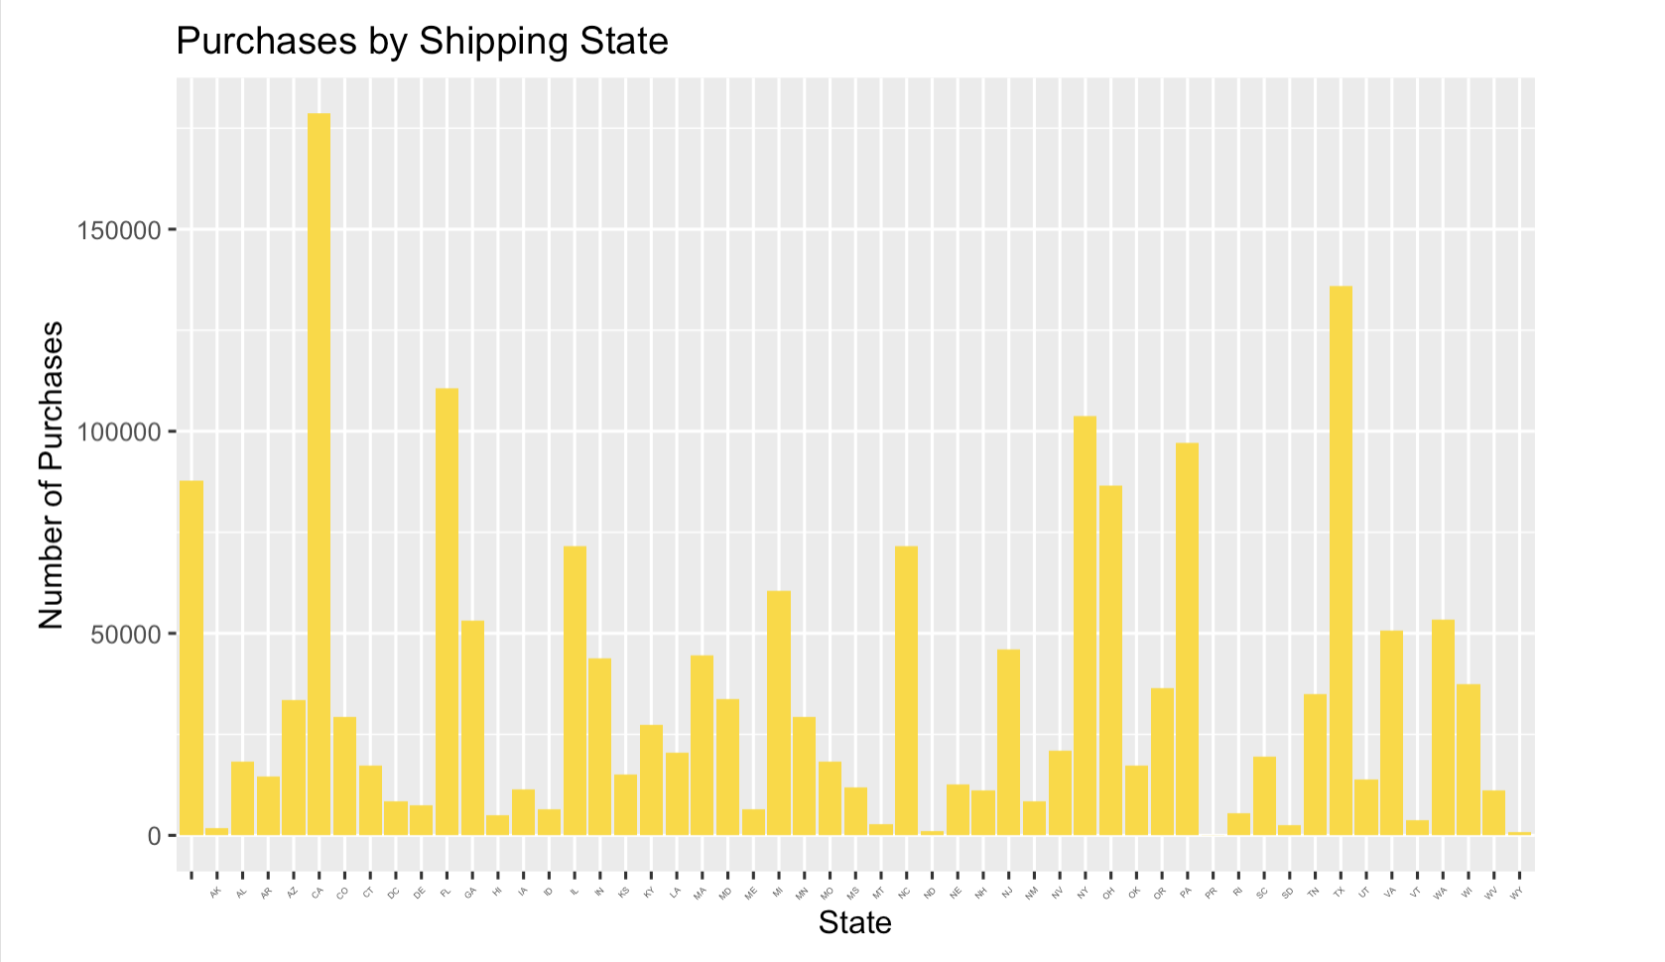

Feature Engineering/Preprocessing

In this stage, in addition to the two predictors, state (calculated based on the most recent order) and Gender we had from the survey dataset, we engineered features that we believed could predict the number of individuals in a household. In order to do this, we first aggregated the Amazon purchases dataset by response ID. We engineered the following predictors: total purchase amount, average unit price, average number of items in an order (where one day is one order), unique number of items, unique number of categories, order frequency days (# of days between first and last order / unique order dates), total number of orders, order period days (total number of days between a user’s first and last recorded purchase), orders per day, child/pet/grocery/bed indicator dummy variables, total number of weekday orders, total number of weekend orders, most ordered day, unique states, Christmas time orders, back to school time orders, total number of orders by day (7 total), grocery/child/bed quantity, and average quantity indicators (where we classified low average quantity as less than 1.026, high average quantity as more than 1.067, and medium quantity as between 1.026 and 1.067). More detailed descriptions of the variables mentioned above can be found below.

Child Indicator
The child indicators variable identifies product categories in the purchases dataset that indicate the presence of children in a household. The categories include items associated with babies, such as baby bottles, car seats, and cribs, as well as with children, such as toys, puzzles, and school supplies. We used ChatGPT to go through and filter the thousands of available categories. When households purchase products from these categories, it could potentially indicate that the household likely has at least one child, which would in turn raise the household size value. The variable can also be used to estimate the number of children in the household when combined with purchase frequency per household.

Pet Indicator
The pet indicator variable identifies product categories in the purchases dataset that indicate the presence of pets in a household. The categories include items associated with pets, including pet food, pet supplies, and pet toys. We used ChatGPT to go through and filter the thousands of available category columns. Households that purchase these items can be inferred to own pets. Pet ownership is more common in larger households, since larger houses have more space to hold pets and because families are more likely to have pets than single-person households.

Household Indicator
The household indicator variable identifies product categories in the purchases dataset that represent common household furniture such as chairs, desks, beds, and related items. We used ChatGPT to go through and filter the thousands of available category columns. These categories are likely used in homes and can identify the living arrangements of a household. The more items purchased in this category, the more likely the household is to be large.

Order Period Days
The order period days variable evaluates the total number of days between a user’s first and last Amazon order. For each person, it takes the latest order date and subtracts the earliest date, converting the result to a numeric value in days. This gives the length of the observation window for that user, which is important as context to understand frequencies. This variable is utilized for the order frequency variable to contribute to determining the household size.

Orders Per Day
The orders per day variable measures the average number of orders per day for a household, transformed with log to reduce the skew from households observed in the charts from households with very high ordering rates. It is calculated by taking the orders variable and dividing it by the maximum order period days. Higher values indicate households that order more frequently and larger household sizes. Therefore, including this variable allows the model to leverage ordering frequency for predictions of household size.

Order Frequency
The order frequency variable takes the average gap in days between ordering dates per user. It's computed by taking the earliest and latest order date as in the order period days variable to get the span in days. It then counts the number of unique order dates, which are the unique days on which at least one order happened. The range of order period days is then divided by the number of unique days. The variable estimates how spread out each user’s ordering days are, where a smaller value indicates more frequent ordering. A higher order frequency could indicate a larger household, given that more people would lead to more orders.

Orders Weekday and Weekend
The orders weekday variable takes the sum of orders that fall under Saturday or Sunday. The orders weekday variable takes the sum of orders that fall under Monday, Tuesday, Wednesday, Thursday, or Friday. By separating weekend and weekday activity, the model can detect patterns in purchasing behavior that correlate with household size (temporal ordering trends).

Most Ordered Day
The most ordered day variable identifies the day of the week on which the user orders most often. It is conducted by creating a frequency table of weekdays for each user and then identifying which day has the maximum count and taking the name. The variable is then factored to convert into an indicator. This captures a preferred day for behavioral insights (temporal ordering trends).

Orders Monday through Sunday
The seven indicator variables count the number of orders for each weekday. It is computed by evaluating the weekday of the order day to provide a day-of-week overview to see how orders are distributed across the week. The distribution allows models to detect patterns that correlate with certain household types. For example, consistently high weekday ordering could correlate with certain income and job types to contribute to household predictions. This is similar to the Orders Weekday and Weekend variable but a more precise breakdown of temporal ordering trends.

Christmas and Back-to-School Orders
The variable captures the proportion of orders placed from November 28th, until the 26th of December, which indicates the end of Christmas time. It is computed by identifying orders within the dates “11-28” and “12-26”. The mean of this vector gives the proportion of orders in the holiday period. This captures the holiday-related order fluctuation, which contributes to identifying seasonal shopping behavior. Large households will show more spikes around this time period, especially if there are kids in the household.

Average Quantity
The average quantity variable captures the average of the quantity variable and is logged to reduce skew from large orders. Higher values indicate households that purchase more items per order, corresponding with larger household size.

Average Quantity per User Categories: Low, Medium, and High
These three dummy variables organize users into one of three categories: low average quantity, medium average quantity, and high average quantity. The process begins by computing the 33rd and 67th percentiles of the average quantity across users. Split 1 is the value below which around one-third of users fall (low order quantity). Split 2 is then created to determine the cutoff between medium and high quantity users. With these thresholds, each user will fall into one of three categories. These indicators will determine if the average quantity is skewed based on behavior rather than a simple linear relationship between quantity purchased and true household size.

Child/Grocery/Household/Bed/Pet Quantity
Each variable measures the log-transformed quantity of items that fall under the categories provided (from the child, grocery, household, bed, and pet categories). Higher values indicate households that correlate with larger household sizes.

Unique Items
The variable counts the total number of distinct products purchased by a household. It is determined by taking the length of unique product codes. Larger households tend to purchase a greater number of unique items for their separate members.

Unique Categories
The variable counts the total number of distinct categories purchased by a household. It is determined by taking the length of unique categories. Larger households tend to have more diverse category purchases, especially given that each individual will have their own tastes and purchasing behaviors.

Unique States
The variable counts the number of unique shipping states associated with a household’s orders. It is determined by taking the length of the unique shipping address state. Having many shipping states may indicate a larger household, with people such as college students or dispersed family members. Therefore, it can reflect household size.

Candidate models / Model evaluation / Tuning

Lasso
This model implemented lasso using the regr.cv_glmnet learner in the mlr3 package to predict the number of individuals in each household. Since Lasso regression automatically performs feature selection by shrinking the coefficients of some variables to zero, we chose to fit this model first in order to gauge which predictors contributed most and least to our prediction of household size.

Model Interpretation
The variables which do not contribute meaningfully to predicting household size were removed from the model. For our model, 76 predictors were set to zero out of 99. Please note that 40 of those 76 predictors set to zero were one hot encoded feature indicating the state of the individual.
Below is a figure demonstrating the top features by importance. We have intentionally left the 50 one hot encoded variables for state out of this visualization as each variable only applies to a small subset of the data. In the visualization below we have some interesting findings. Specifically, we would predict people with a higher percentage of their total orders around the holidays and around back to school time to have more members in their household. Additionally, those that have many items ordered with a category related to children are predicted to have larger household sizes. Those with gender reported as other or with many pet items ordered would be predicted to have a slightly smaller household size. To make this concrete, I will demonstrate a prediction that the model makes on two different amazon accounts in the test set by looking at a few of their features. For this first example, we predict 0.613 household members which clearly does not make sense as we should not have less than one household member. However, this is likely the case because this account performs poorly on the three main features that indicate larger households– the quantity of orders with child related categories and the percent of total orders during the Christmas season and back to school season. Alternatively, the second observation has a predicted household size of 3.905 which is very close to the largest household size in this dataset of 4. This is due to the fact that this user has almost 12% of their orders in the month-long Christmas season when that season only makes up about 8% of the year. This user also has exp(3.295837) = 27 orders in child related categories which boosts their predicted household members.
Survey ID | Predicted Household Members | Christmas order percentage | Back to school percentage | log_child _quantity
R_111J2YLIGckNIeJ | 0.6133735 | 0.05105105 | 0.05705706 | 0
R_3Kv8PUwM5KE3ZA2 | 3.905233 | 0.1190476 | 0.08658009 | 3.295837

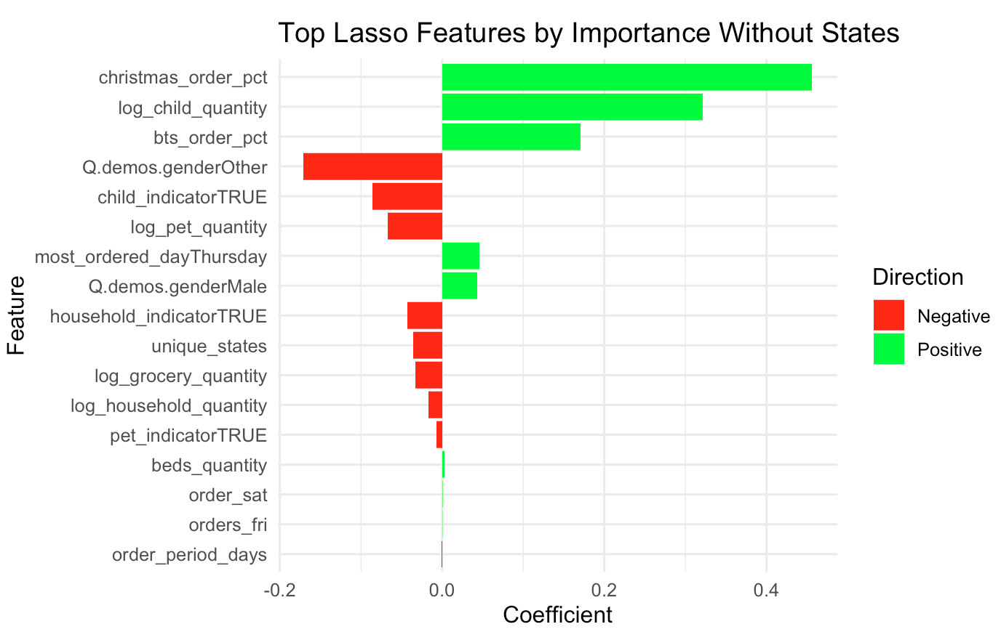

Model Evaluation and Tuning
To measure performance, we used a 10-fold cross validation where we assessed the RMSE and MSE metrics using microaggregation, since the task involves predicting a continuous outcome. Upon using 10-fold cross-validation, we found that our model had a RMSE of 1.037809.
For tuning of the parameter lambda in this model, we used the built in cross validation within the regr.cv_glmnet learner. This automatically selects the lambda with the lowest cross validated MSE from a grid of lambda values that we chose. In our model, the lambda value that minimizes the MSE is 0.01584893.

Ridge Regression
This model implemented Ridge regression using the regr.cv_glmnet learner in the mlr3 package to predict the number of individuals in each household. Unlike Lasso, Ridge regression does not perform variable selection. Instead, it shrinks all coefficients toward zero but never eliminates predictors completely. Ridge is particularly effective when predictors are highly correlated or when we want to stabilize coefficient estimates without removing variables. Because our dataset contains many correlated features (e.g. the different categories of orders), Ridge provides a valuable comparison point to the Lasso model.

Model Interpretation
Unlike Lasso, Ridge regression does not perform variable selection, but we can begin to see many of the coefficients of the predictors shrinking towards zero. Similarly to our Lasso model, the top three predictors that predict a larger household size are still the percentage of orders made during christmas time, the percentage of orders made during back to school time, and the log of the number of items ordered with categories related to children. Some of the predictors that would predict smaller household sizes would be having a gender of other, having your most ordered day be Saturday, or the variable indicating you ordered at least one item in a category related to children. We may have expected this children category indicator variable to be positive, so it is interesting to see this indicator variable with a negative value. The most likely and very probable explanation is that we already have a variable that tracks the number of items ordered with a child related category, log_child_quantity, with an even greater coefficient. In short, having many amazon purchases in children related categories will increase you predicted household size, but having a relatively small number of children related orders might not increase your predicted household size.

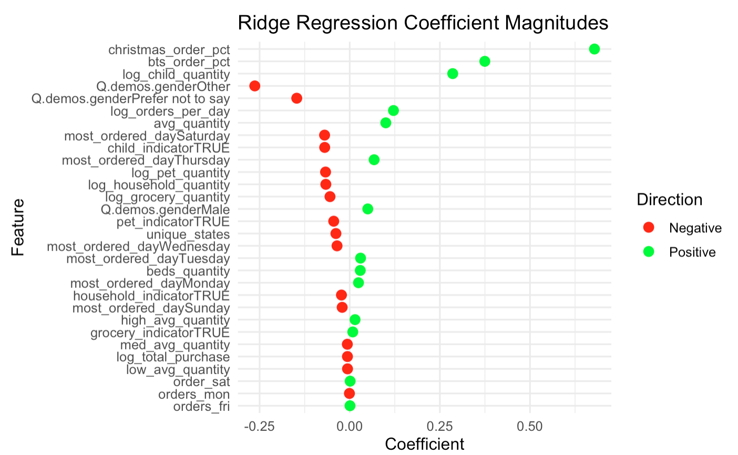

Model Evaluation and Tuning
To measure performance, we used 10-fold cross validation where we assessed the RMSE using micro aggregation, since the task involves predicting a continuous outcome. We found a RMSE of 1.044607.
For tuning of the parameter lambda in this model, we used the same method that we used for lasso above. In our model, the lambda value that minimizes the MSE is 0.1.

Regression Tree
This model implemented a standard regression tree using the regr.rpart learner in the mlr3 package to predict the number of individuals in each household. Since regression trees perform variable selection by choosing splits that minimize prediction error, preprocessing feature selection is not required. Furthermore, we converted all character variables (state, gender, most ordered day) into factors. State, gender, and all engineered predictors, such as total purchase amount, order frequency, and weekday/weekend patterns, were included in the model, enabling the tree to identify nonlinear relationships between the predictor variables and the response variable.

Model Interpretation
The most important variables were identified using the rpart.plot package. As shown below, the initial split of the tree occurred in the number of unique items purchased, with a threshold of 603 items. This variable alone separated the data into two groups where 86% of households purchased fewer than 603 unique items and 14% of households purchased more than 603 unique items. Households purchasing less than 603 unique items had an average predicted household size of 2.4 individuals, while households that purchased more than 603 unique items had an average predicted household size of 2.8 individuals.
Among households with fewer than 603 unique items, the next split occurred on order_period_days (total number of days between a user’s first and last recorded purchase). Households with an order history of 938 days or more tended to have a slightly higher predicted household size at around 2.8 individuals. For households with less than 938 days of order history, a further split occurred on child_indicator (dummy variable denoting whether a household purchased child-related items). Households with at least one child-related purchase tended to have larger predicted household sizes at around 2.4 individuals.
On the branch of households that purchased more than 603 unique items, the next split occurred in certain states (Arizona, Arkansas, Colorado, Delaware, Idaho, Kansas, Maine, Maryland, Nevada, New Jersey, Tennessee, Utah, and West Virginia). If households' most recent purchase were from any of these states, then the model predicted a household size of 3.0 individuals, whereas if it were from any other states, it predicted a household size of 2.2 individuals.
As an example, if a household had 550 unique items, 900 order days, and had a child related purchase, the regression tree would predict the household size to be 2.4. Furthermore, if a household has 650 unique items and the most recent purchase came from Maine, then the regression tree would predict the household size to be 3.0.
Overall, our regression tree model predicted that purchasing breadth (unique items), length of order history, presence of child-related purchases, and state demographic differences are the most powerful predictors to predict household size.

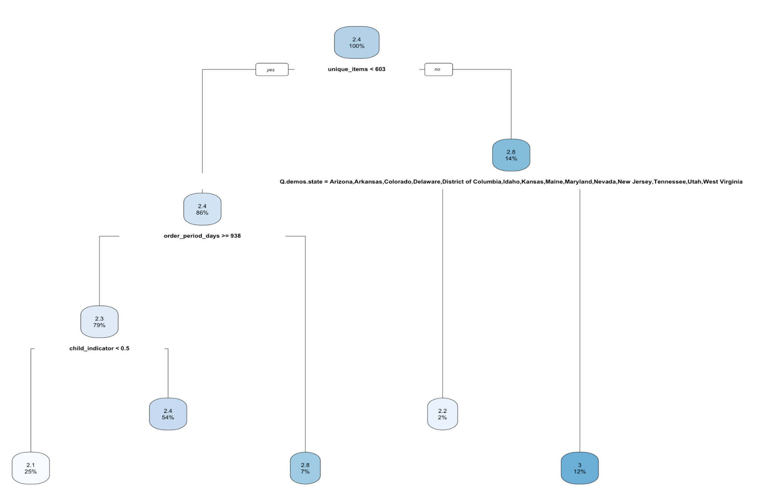

Model Evaluation and Tuning
To measure performance, we used a 10-fold cross validation where we assessed the RMSE and MSE metrics using microaggregation, since the task involves predicting a continuous outcome. Upon using cross-validation, we found that our regression tree had a RMSE of 1.055748.
The regression tree underwent tuning to test parameters minsplit (minimum number of observations required at a node) and maxdepth (number of levels). Using gridsearch, we tested 10 values of minsplit (between 2 - 100) and maxdepth (between 0 - 30), and we tested all the combinations (100 total) between the two. The tuning output indicated that the optimal parameter values were almost identical to the defaults because it produced the exact same splits, predictors, and overall tree structure as the vanilla model. This may be particularly due to not testing the complexity parameter (cp) of the regression tree. As a result, even though different parameter combinations were investigated, the final tree remained the same and tuning did not yield improvements.

Random Forest
In this model, we modeled both a vanilla Random Forest model (for reference) and a tuned Random forest model using the ranger package with permutation-based variable importance. Random Forest aggregates predictions across many bootstrapped trees, each trained on a random subset of predictors.

Model Interpretation
The variable importance plot (using permutation importance) revealed variables that were significant in predicting the number of individuals in a household. Variables such as order frequency, unique number of items, and quantity of orders for products in a child related category were most important in our model. To further test which variables have low or no significance in our model, we created a “trash” variable that represented random noise. Variables that had similar or lower importance as the “trash” variable were interpreted to have little predictive power, indicating that their influence was due to random chance, not because an actual relationship between the predictor and response variable existed. Variables such as avg_quantity, state, gender, grocery indicator had low predictive power.

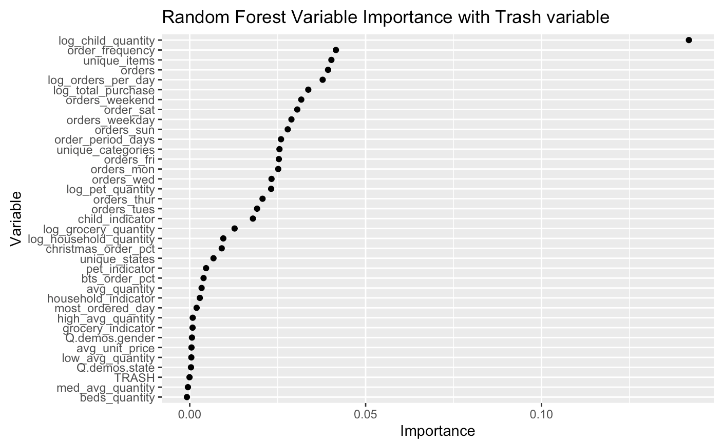

Model Evaluation and Tuning
To measure performance, we used a 10-fold cross validation where we assessed the RMSE and MSE metrics using aggregation. Upon cross-validation, we found that our tuned random forest model had a RMSE of 1.033707.
The random forest underwent tuning to test parameters maximum depth (number of maximum depth of the tree), and min.node.size (minimum terminal node size). Using gridsearch, we tested 4 values of maximum depth (between 2-10) and min.node.size (between 1 - 50), and all combinations (16 total) between the two. The tuning output indicated that the optimal parameter values of max.depth was 10 and min.node.size was 17. The result RMSE improved from the vanilla random forest model and decreased from 1.040146 to 1.033707.

XGBoost
In this model, we modeled both a vanilla XG Boost (for reference) and a tuned XG boost model. We used one-hot encoding to convert categorical variables into separate binary columns for each category because XGBoost requires all input features to be numeric.

Model Interpretation
The permutation variable importance plot revealed variables that were significant in predicting the number of individuals in a household. Like Random Forest’s variance importance plot, log child quantity was the most important variable in predicting household size. However, XGBoost’s variance importance plot found variables such as order period days, quantity, avg unit price, christmas order percentage, and back to school order percentage as also strong variables to predict household size.

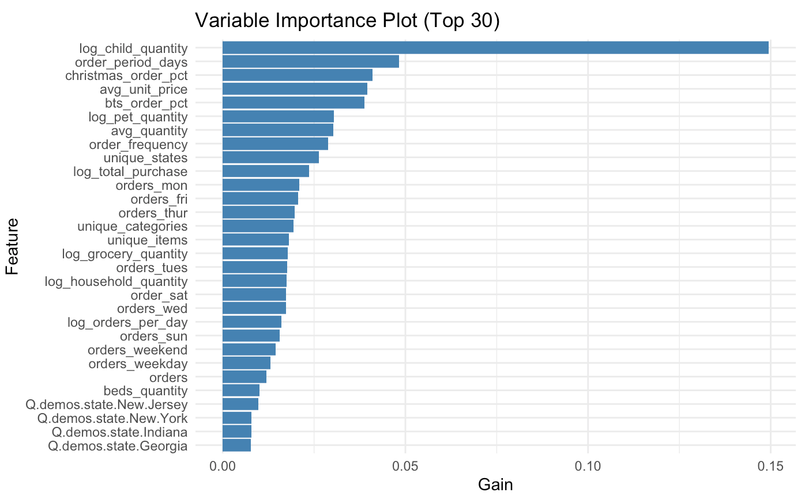

Model Evaluation and Tuning
To measure performance, we used a validation set where we assessed the RMSE. On the validation set, we found that our tuned XGBoost had a RMSE of 1.006801. Due to the computational complexity it would have taken to undertake 10-fold cross validation, we understand that our estimate of RMSE has much higher variance that our other estimate which makes it slightly less reliable.
The XGBoost model underwent tuning to test parameters eta, max_depth, subsample, colsample_bytree, colsample_bylevel, alpha, and lambda. We used a 67/33% train-validation split to find optimal hyperparameters. The hyperparameters were found to be eta = 0.0191, max_depth = 14, colsample_bytree = 0.476, colsample_bylevel = 0.823, lambda = 3.467799, alpha = 23.7, and subsample = 0.7412741 The tuned XGBoost model RMSE improved significantly from the vanilla XGBoost model and decreased from 1.123883 to 1.006801. However, we believe that this new estimate for RMSE is slightly biased as it was not generated in the same way as the other cross validated RMSE values due to computational costs.

Generalized Additive Model
This model uses natural cubic splines on numeric predictors, which allows for non-linear effects between predictors and outcome by using smoothing functions for numeric predictors. The model includes all numeric variables in df_train, and factor variables are handled with one-hot encoding. We used natural cubic splines to shrink numeric predictors for non-linear effects while avoiding overfitting.

Model Interpretation
We examined the strongest predictors using a variable importance plot, determined by effective degrees of freedom in each term. We identified the total purchase amount to be the strongest indicator, followed by unique categories, order frequency, order period days, and average quantity.
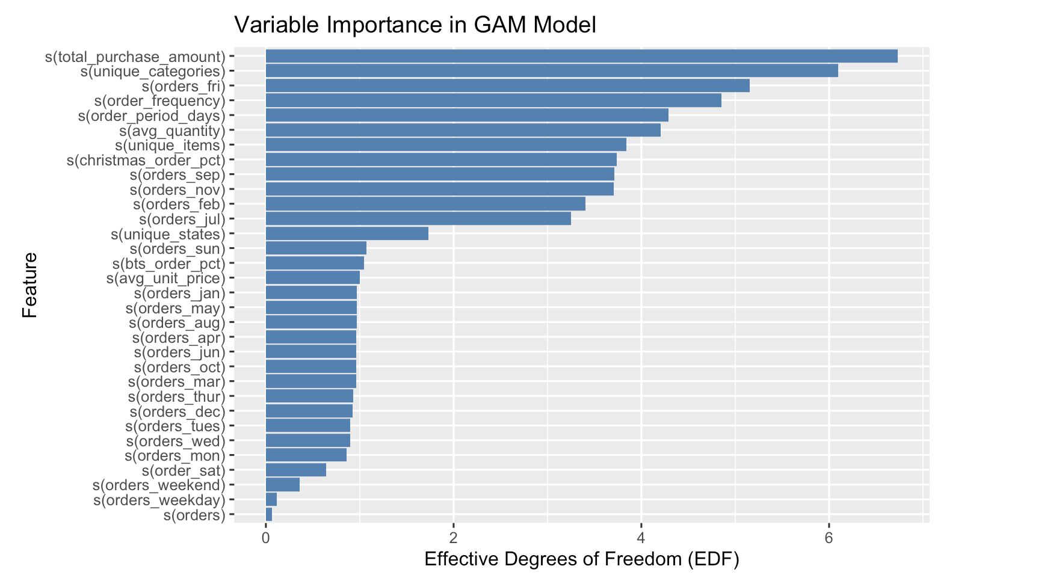
For three example households, the GAM model predicted total purchase behavior based on demographic and ordering features. For example, a household in California with a high average unit price and few unique items had the highest predicted value of 2.63 people. Another household in New York had a predicted value of 2.18 with lower average unit prices.

Model Evaluation and Tuning
We used a maximum basis function of 10 (k_max = 10) to allow moderate flexibility in capturing non-linear effects. Smoother parameters were automatically estimated. To measure performance, we used 10-fold cross-validation, where we assessed the RMSE and MSE using micro aggregation. We found that our final model outputs an RMSE of 1.080875.

Performance Summary:
Model | Metric Score (Validation RMSE; from 10CV) | Variables | Hyperparameters
Lasso | 1.038681 | All (model selected X) | Lambda = 0.01584893
Ridge | 1.044333 | All variables | Lambda = 0.1
GAM | 1.093597 | All variables | N/A
Vanilla Regression Tree | 1.063569 | All variables | Default
Tuned Regression Tree | 1.055748 | All variables | Cp = 0.01, maxdepth = 30, min_split = 20
Vanilla Random Forest | 1.040146 | All variables | Default
Tuned Random Forest | 1.034126 | All variables | max.depth = 10 min.node.size = 17
XG Boost | 1.123883 | All variables | Default Values:  Eta = 0.3, max_depth = 6 colsample_bytree = 1, colsample_bylevel = 1, lambda = 1, alpha = 0, subsample = 1
Tuned XG Boost | 1.006801 (validated on 1/3rd of the training data– not as rigorous an estimate) | All variables | Eta = 0.0191, max_depth = 14, colsample_bytree = 0.476, colsample_bylevel = 0.823, lambda = 3.467799, alpha = 23.7, subsample = 0.7412741

Discussion of Final Model
Model Selection:
The tuned Random Forest model was ultimately selected for generating our final predictions. We were between choosing this model, XGBoost, and lasso as some of our final model candidates. This Random Forest model has a 10-fold cross validated RMSE of 1.034126 which was slightly less than Lasso’s 1.038681 RMSE. We believe that this Random Forest model may have performed slightly better than Lasso due to its ability to capture non linear relationships and more complex patterns in the data. However, the difference between the two prediction capabilities was not too great. Additionally, we chose to select this Random Forest model over the XGBoost model even though the estimated RMSE was lower for the XGBoost model. We made this decision for two reasons. First our estimate for RMSE was not based on 10-fold cross validation due to computational constraints, so it seemed to estimate a lower RMSE than true cross validation. The second reason is that the Random Forest model is a slightly simpler model than XGBoost– making it slightly easier to tune and more preferred.

Strengths and Weaknesses:
- Strengths: One strength of our Random Forest model is that it is an ensemble method– it uses multiple trees to come to its conclusions which makes it less likely to overfit the data. Additionally,
- Weaknesses: One weakness of our random forest model is interpretability. While we can still create variable importance plots to gauge the importance of the various predictors, having multiple highly correlated predictors can diminish the individual importance of each of those predictors, sometimes obscuring the exact effects of each predictor variable. Another weakness of our model is that it is fairly computational expensive– at least with respect to models such as lasso or a generalized additive model.

Possible Improvements:
The most obvious improvement that we could make is in the feature engineering step. Since almost all of our potential predictor variables come from over one million different amazon orders, there is a lot of flexibility in engineering features that will predict household size. While we were able to generate some pretty important features such as the number of items ordered in child related categories, there is definitely room to discover other features that can explain household size even better. Additionally, we definitely had room to test more hyperparameters for this random forest model. Tuning across a few more hyperparameters could have potentially improved cross validated RMSE and RMSE on unseen data. Lastly, additional data would always greatly help improve prediction accuracy. Demographic data about the amazon user beyond gender and state such as education or salary would likely be very helpful in predicting household size.

External sources:
https://capitaloneshopping.com/research/amazon-orders-per-day/

